#include<bits/stdc++.h>

using **namespace** std;

#define INF **int**(1e9)

using u_map=unordered_map<**int**,**int**>;

**struct** Process{

**int** process_num,arrival_time,burst_time;

};

**struct** Process_idx{

Process pr;

**int** idx;

};

**double** calc_avg(**int** n, u_map**&** m){

**double** avg=0;

for(**auto** i:m)

avg+=i.second;

avg/=n;

return avg;

}

*// First Come First Serve Scheduling Algorithm*

**void** fcfs(**int** n_process, vector<Process>**&** p, u_map**&** ct, u_map**&** tat, u_map**&** wt, **double&** avg_wt, **double&** avg_tat){

sort(p.begin(), p.end(), [](Process a,Process b){

if(a.arrival_time==b.arrival_time)

return a.process_num<b.process_num;

return a.arrival_time<b.arrival_time;

});

**int** tim=0;

for(**auto** i:p){

**int** p_num=i.process_num;

**int** at=i.arrival_time;

**int** bt=i.burst_time;

tim+=bt;

ct[p_num]=tim;

tat[p_num]=tim-at;

wt[p_num]=tat[p_num]-bt;

}

avg_wt=calc_avg(n_process,wt);

avg_tat=calc_avg(n_process,tat);

}

*// Shortest Job First Scheduling Algorithm*

**void** sjf(**int** n_process, vector<Process>**&** p, u_map**&** ct, u_map**&** tat, u_map**&** wt, **double&** avg_wt, **double&** avg_tat){

sort(p.begin(), p.end(), [](Process a,Process b){

if(a.arrival_time==b.arrival_time)

return a.burst_time!=b.burst_time?a.burst_time<b.burst_time:a.process_num<b.process_num;

return a.arrival_time<b.arrival_time;

});

unordered_map<**int**,**bool**> finished;

**int** process_completed = 0;

**int** tim=0;

while(process_completed<n_process){

**int** idx=-1;

**int** min_burst_time=INF;

for(**int** i=0;i<n_process;i++){

**int** p_num=p[i].process_num;

**int** bt=p[i].burst_time;

**int** at=p[i].arrival_time;

if(finished[p_num]||at>tim)

continue;

if(bt<min_burst_time){

idx=i;

min_burst_time=bt;

}

else if(bt==min_burst_time&&at<p[idx].arrival_time){

idx=i;

min_burst_time=bt;

}

}

if(idx!=-1){

**int** p_num=p[idx].process_num;

**int** bt=p[idx].burst_time;

**int** at=p[idx].arrival_time;

tim+=bt;

ct[p_num]=tim;

tat[p_num]=tim-at;

wt[p_num]=tat[p_num]-bt;

finished[p_num]=true;

process_completed++;

}

else

tim++;

}

avg_wt=calc_avg(n_process,wt);

avg_tat=calc_avg(n_process,tat);

}

*// Shortest Remaining Time First Scheduling Algorithm*

**void** srtf(**int** n_process, vector<Process>**&** p, u_map**&** ct, u_map**&** tat, u_map**&** wt, **double&** avg_wt, **double&** avg_tat){

sort(p.begin(), p.end(), [](Process a,Process b){

if(a.arrival_time==b.arrival_time)

return a.burst_time!=b.burst_time?a.burst_time<b.burst_time:a.process_num<b.process_num;

return a.arrival_time<b.arrival_time;

});

vector<Process>p_temp=p;

unordered_map<**int**,**bool**>finished;

**int** process_completed=0;

**int** tim=0;

while(process_completed<n_process){

**int** idx=-1;

**int** min_burst_time=INF;

for(**int** i=0;i<n_process;i++){

**int** p_num=p_temp[i].process_num;

**int** bt=p_temp[i].burst_time;

**int** at=p_temp[i].arrival_time;

if(finished[p_num]||at>tim)

continue;

if(bt<min_burst_time){

idx=i;

min_burst_time=bt;

}

else if(bt==min_burst_time&&at<p_temp[idx].arrival_time){

idx=i;

min_burst_time=bt;

}

}

if(idx!=-1){

p_temp[idx].burst_time--;

tim++;

if(p_temp[idx].burst_time==0){

**int** p_num=p_temp[idx].process_num;

ct[p_num]=tim;

tat[p_num]=tim-p_temp[idx].arrival_time;

wt[p_num]=tat[p_num]-p[idx].burst_time;

process_completed++;

finished[p_num]=true;

}

}

else

tim++;

}

avg_wt=calc_avg(n_process,wt);

avg_tat=calc_avg(n_process,tat);

}

*// Round Robin Scheduling Algorithm*

**void** rr(**int** n_process, vector<Process>**&** p, **int** tq, u_map**&** ct, u_map**&** tat, u_map**&** wt, **double&** avg_wt, **double&** avg_tat){

sort(p.begin(), p.end(), [](Process a,Process b){

if(a.arrival_time==b.arrival_time)

return a.process_num<b.process_num;

return a.arrival_time<b.arrival_time;

});

vector<Process>p_temp=p;

unordered_map<**int**,**bool**>added;

queue<Process_idx>ready_queue;

ready_queue.push({p[0],0});

**int** p_completed=0;

**int** temp=0;

**int** ctr=tq;

**int** tim=p[0].arrival_time;

while(p_completed<n_process){

Process_idx pr_idx=ready_queue.front();

Process pr=pr_idx.pr;

**int** idx=pr_idx.idx;

ready_queue.pop();

added[pr.process_num]=true;

while(ctr>0&&pr.burst_time>0){

ctr--;

pr.burst_time--;

tim++;

for(**int** i=temp+1;i<n_process;i++,temp++){

if(p[i].arrival_time>tim)

break;

ready_queue.push({p[i],i});

}

}

p_temp[idx].burst_time=pr.burst_time;

if(pr.burst_time==0){

ct[pr.process_num]=tim;

tat[pr.process_num]=tim-pr.arrival_time;

wt[pr.process_num]=tat[pr.process_num]-p[idx].burst_time;

p_completed++;

}

else

ready_queue.push({p_temp[idx],idx});

ctr=tq;

if(ready_queue.empty()){

for(**int** i=temp+1;i<n_process;i++,temp++){

ready_queue.push({p[i],i});

tim=p[i].arrival_time;

break;

}

}

}

avg_wt=calc_avg(n_process,wt);

avg_tat=calc_avg(n_process,tat);

}

**int** main(){

**int** n_process;

cin>>n_process;

vector<Process>p;

for(**int** i=0;i<n_process;i++){

**int** process_num,arrival_time,burst_time;

cin>>process_num>>arrival_time>>burst_time;

p.push_back({process_num,arrival_time,burst_time});

}

**int** tq;

cin>>tq;

u_map ct_fcfs,tat_fcfs,wt_fcfs;

u_map ct_sjf,tat_sjf,wt_sjf;

u_map ct_srtf,tat_srtf,wt_srtf;

u_map ct_rr,tat_rr,wt_rr;

**double** avg_wt_fcfs,avg_tat_fcfs;

**double** avg_wt_sjf,avg_tat_sjf;

**double** avg_wt_srtf,avg_tat_srtf;

**double** avg_wt_rr,avg_tat_rr;

fcfs(n_process,p,ct_fcfs,tat_fcfs,wt_fcfs,avg_wt_fcfs,avg_tat_fcfs);

sjf(n_process,p,ct_sjf,tat_sjf,wt_sjf,avg_wt_sjf,avg_tat_sjf);

srtf(n_process,p,ct_srtf,tat_srtf,wt_srtf,avg_wt_srtf,avg_tat_srtf);

rr(n_process,p,tq,ct_rr,tat_rr,wt_rr,avg_wt_rr,avg_tat_rr);

for(**int** i=0;i<n_process;i++){

**int** p_num=p[i].process_num;

cout<<p_num<<" -> \t"<<tat_fcfs[p_num]<<"\t"<<wt_fcfs[p_num]<<"\t"<<tat_sjf[p_num]<<"\t"<<wt_sjf[p_num]<<"\t"<<tat_srtf[p_num]<<"\t"<<wt_srtf[p_num]<<"\t"<<tat_rr[p_num]<<"\t"<<wt_rr[p_num]<<"\n";

}

cout<<"\n\n";

cout<<avg_tat_fcfs<<"\t"<<avg_wt_fcfs<<"\t"<<avg_tat_sjf<<"\t"<<avg_wt_sjf<<"\t"<<avg_tat_srtf<<"\t"<<avg_wt_srtf<<"\t"<<avg_tat_rr<<"\t"<<avg_wt_rr<<"\n";

return 0;

}

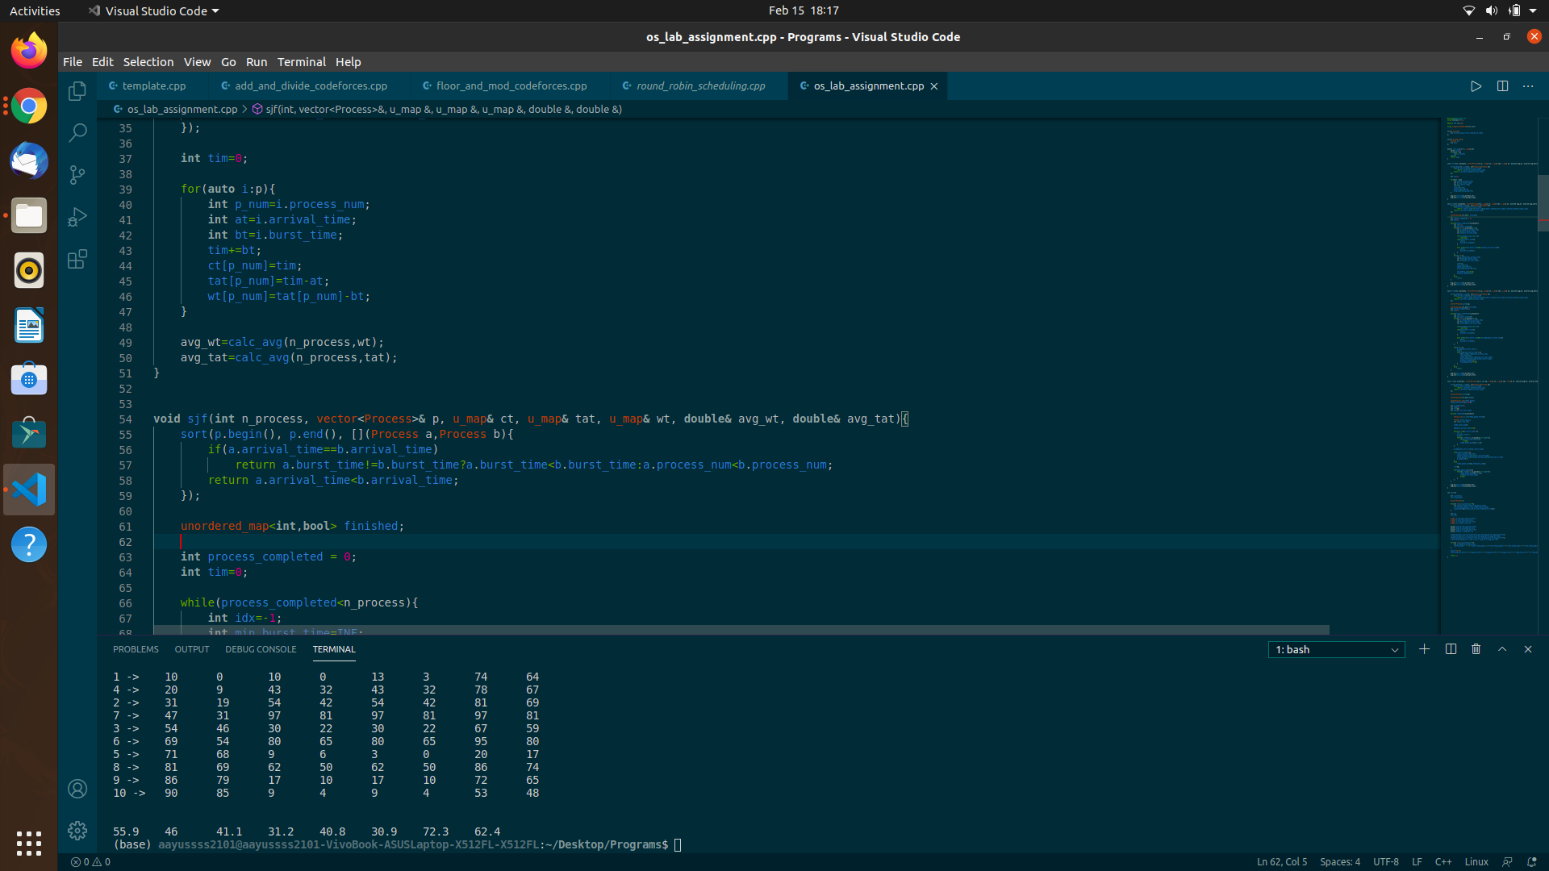

In my opinion SRTF is the best algorithm for this problem as it has the least average turnaround time and average waiting time.